**Website details: in (Arabic & English)**

**Name:**  in peace we live

**About me section:**

**Or the first page pop up when open the web**

Salam (means peace & greeting in Arabic) (you can use it in any way you like).

if you love adventure, animal, nature, mystery, hope, faith then you are in the right place …

**My name:** Shouq Alsulaiman

**From where?** Kuwait

**Logo:** picture of the logo under it this(in every dark moment there is light if you allow the darkness to show you & if you allow your old skin that doesn’t server you to fall you will feel alive again) if you are ready, I am here to guide you in this journey…

**My journey:** (short story) stared in high school to face stress that hurt my heath and founds meditation at age of 16/ 15 years to help me relive stress then graduated to face more than stress studying abroad, faced life changing decision making, channelings, pain, frustrations, lost, loss disappointment, to then decide to go deep within self. See the unseen, & hidden parts of self.

I decide to take healing workshops & classes to help self-first so I can now share my years of lessons & experiences with you with love.

**Why:** I found out that we all can heal our self if we found healthy, supportive community and induvial we can be ourselves without feel of shame or fear.

I host spaces online to connect & remind other there are not alone, & there is always place within us that are filled with peace, bliss and love

**My experiences:**

**Degree:** Master’s in social entrepreneurship (works with homeless in Los Angeles for few months to help them find solutions for their different situations (wants & needs) at university of southern California

This experience made me realize how faith can be found in our darkest moments.

**Certificated :**

* **Internationally Certified Self-Love Master Practitioner & Coach ( Oct 2023)**
* **50-Hour Meditation Teacher Training ( Nov 2023)**
* **Internationally Certified Soul School Practitioner of Channeling & Channel Writing ( March 2024)**
* **Internationally Certified Life Transition Counselor & Coach ( Nov 2023)**
* **Self-Confidence & Empowerment Coach ( Oct 2023)**
* **Alchemy of meditation ( meditation trainning course ) ( March 2024)**
* **Ancestral Healing (Diploma in Progress)**

**Feedback:**

(you can add them in a creative way)

Sessions feedback:

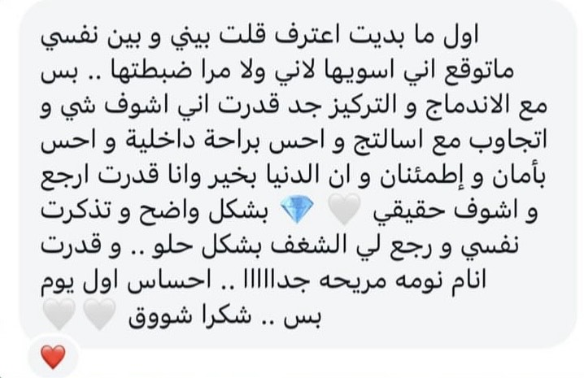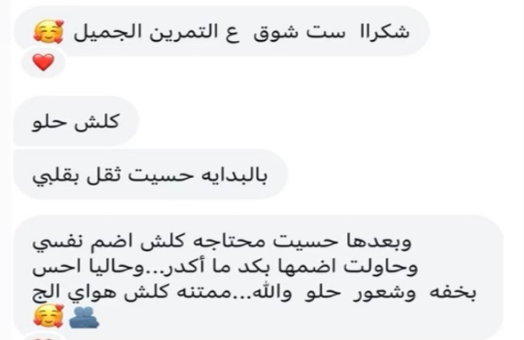

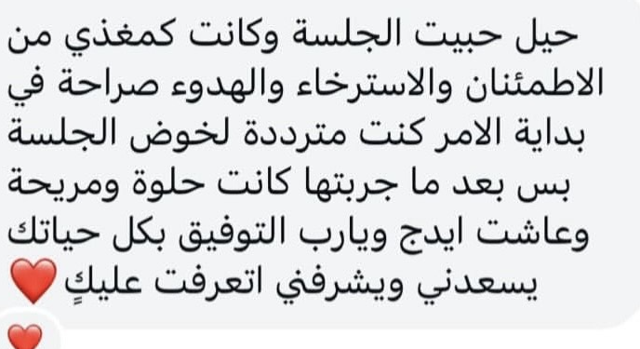

**How to contact me:**

**Email:** [inpeacewelive11@gmail.com](mailto:inpeacewelive11@gmail.com)

**Instagram:** shouqalsulaiman_

**Payments / investment:**

Parts of the cost of the session goes for donation and the donation receipt been sent to the clients

**My services: (don’t add these in the website now, just for reference/context to create the website)**

* Mediations sessions for: stress relief, energy protection & aura & energy cleansing, heart activation, relaxation
* Channeling session: self-discovery

**Web theme:**

**Multie mix color inspiration idea**

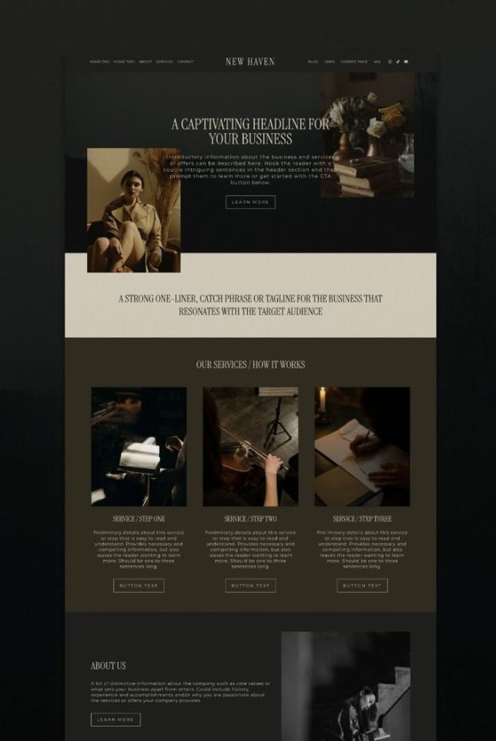

**Pictures theme ideas:**

**(shades of green & pictures inspiration)**

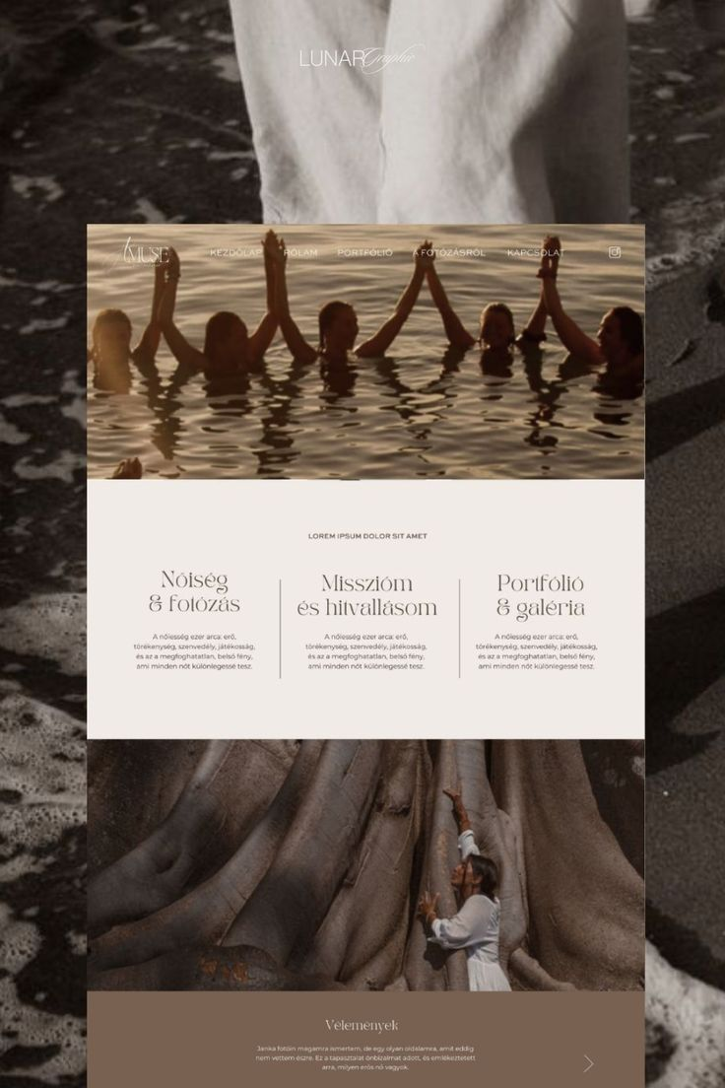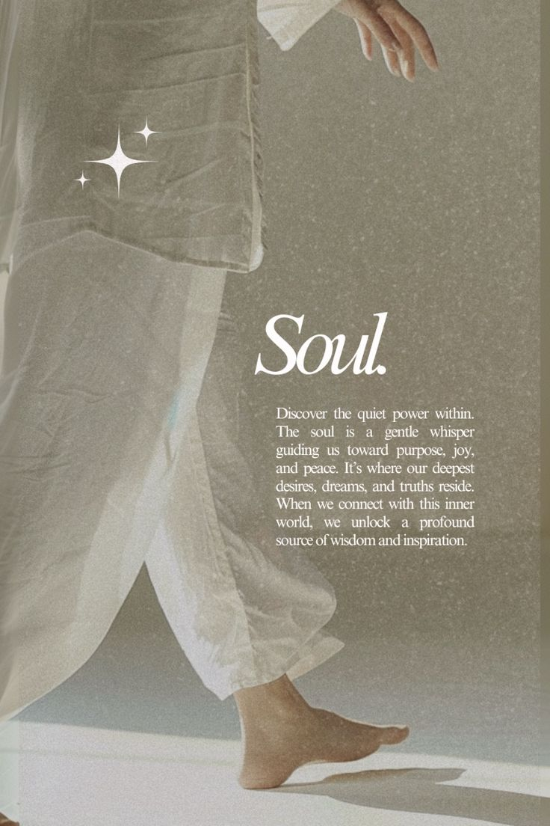

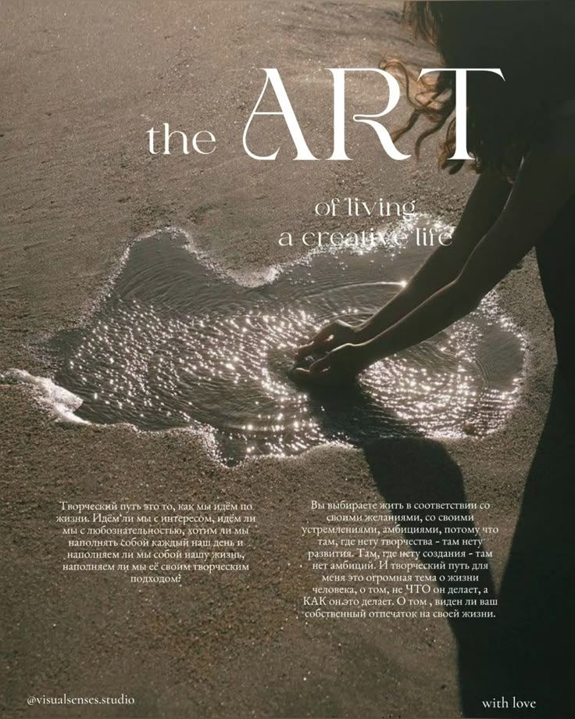

**Logo:**

